Software Requirements Specification
for
Smart assistance for visually impaired people
Version 1.0 approved
Prepared by -
Sanket Satav
Dipashri Jadhav
Samruddhi Wani
Achyut Ratkanthiwar

VIIT, Pune
18/09/2018
Table of Contents
Table of Contents ii
1. Introduction 1
1.1 Purpose 1
1.2 Document Conventions 1
1.3 Intended Audience and Reading Suggestions 1
1.4 Product Scope 1
1.5 References 2
2. Overall Description 2
2.1 Product Perspective 2
2.2 Product Functions 3
2.3 User Classes and Characteristics 4
2.4 Operating Environment 5
2.5 Design and Implementation Constraints 5
2.6 User Documentation 5
2.7 Assumptions and Dependencies 5
3. External Interface Requirements 5
3.1 User Interfaces 5
3.2 Hardware Interfaces 5
3.3 Software Interfaces 6
4. System Features 6
4.1 Laser 7
4.2 Lidar 7
4.3 Camera 7

5. Other Nonfunctional Requirements 7
5.1 Performance Requirements 7

Introduction

Purpose
Safe mobility is among the greatest challenges faced by the visually challenged in dayto-day life. They use the white cane as a mobility aid to detect close-by obstacles on the ground.

- To module a technical aid ,which can assist visually impaired people in there day-to-day routines.
- A wearable device or hand held smart white cane to be made which can guide them without the overhead of carrying anything extra with them.
- Using the technology for social help cause

Document Conventions
L | Left
F | Front
R | Right
LASER | Light Amplified by Simulated Emission of Radiation
LIDAR | Light Detection and Ranging

Intended Audience and Reading Suggestions
This project is a prototype of Smart Assistance for visually impaired people and it is intended to be used in real life. This has been implemented under the guidance of college professors. This project is useful for the visually impaired people.

Product Scope
- To build a model which can detect objects, recognize them, give the responsive output to user to tackle the aroused situation.
- Through image processing, and using sensor output assist user.
- Provide ease of access to the model through mobile application.
- To help visually impaired people to experience the scene around and help them walk around freely.

References
- https://www.ijireeice.com/upload/2015/may-15/IJIREEICE%2028.pdf
- Seeing AI By Microsoft : https://www.microsoft.com/en-us/seeing-ai
- Medium Blog : https://medium.com/tag/machine-learning
- GeeksforGeeks :https://www.geeksforgeeks.org/project-idea-third-eye-aid-for-blind/
- PyImageSearch : https://www.pyimagesearch.com/

Overall Description

Product Perspective

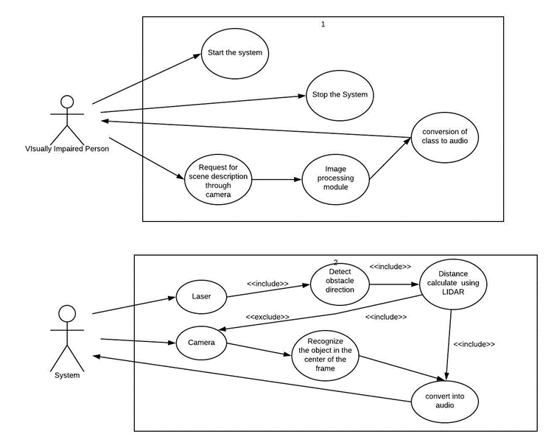

Product Functions
The major features of this system is as shown below in the diagram:

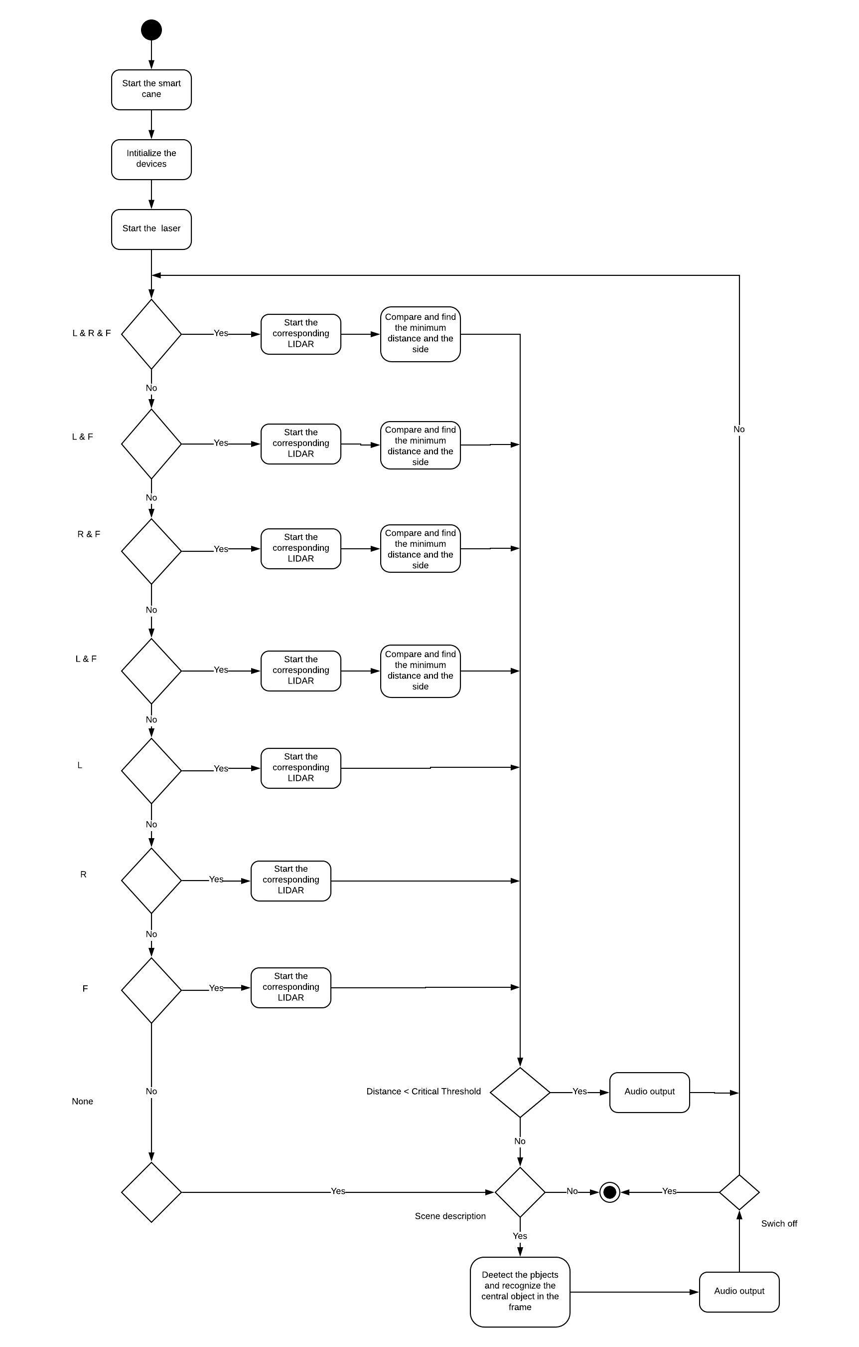

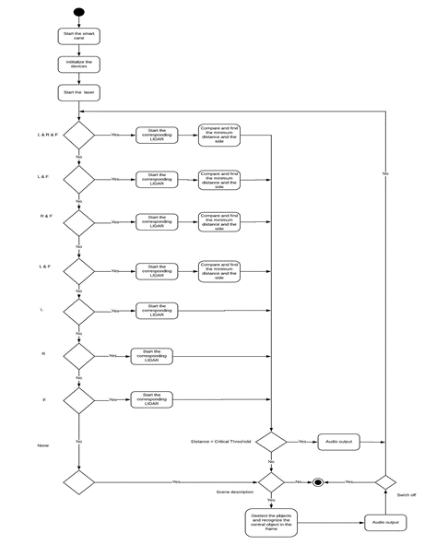

User Classes and Characteristics

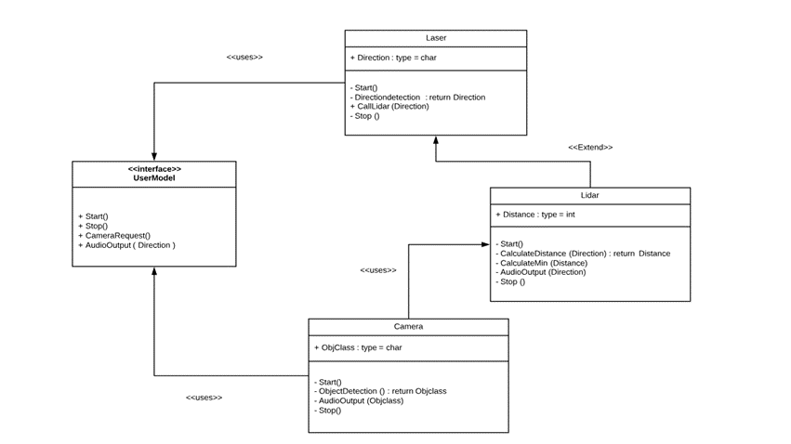

Operating Environment
Operating environment for this system is as listed below:

- distributed database
- client/server system
- Operating system: Windows.
- database: sql+ database
- platform: vb.net/Java/PHP

Design and Implementation Constraints
- Efficiency regarding high speed moving objects
- Battery Backup
- Weight of total setup
- Scene detection using camera
- Collision rate
- Restricted range
- inability to detect knee-above obstacles

Assumptions and Dependencies
The system is designed as a detachable unit that a user can mount on his/her white cane. It complements and enhances the functionality of the traditional cane. The device is user-detachable, light-weight and possesses Braille markings. An ergonomic design allows the user to hold the Smart Cane with a variety of personalized grips.

User Interfaces
- Android interface:

- For easy access to process the outputs provided by various sensors in the smart cane.
- To access the GPS system.
- Ease the overall function of the system.

Hardware Interfaces
- Buttons provided to access the features of the cane and the camera.
- Audio output to notify the user.
- Sensors like LIDAR, LASER, Ultrasonic etc.
- Camera module for visualize the scene.

Software Interfaces
- Raspberry Pie to integrate all the sensors and their output and to process data accordingly to avoid the obstacles.
- Android application to give ease of access to each module of the system and find the cane.

System Features
We developed a novel navigation aid called the Smart Cane that detects hazardous raised obstacles and increases detection range to 3m, thereby improving safety for the blind user. Initial design. Next, we summarize the key design and usability features of the device.

Laser Module

Android Module

Lidar Module

Raspberry Pi Module

Audio Module

Text To Speech

Camera Module

LASER
As soon as the system is initialized,the laser starts working. It detects the obstacle in left, right and front direction. Depending on the direction detected of the obstacle, in passes input to the LIDAR sensor for further calculations.

LIDAR
It gets input from the LASER. Depending on the input, it will detect the distance of the obstacle in that direction. If there is obstacle in more the one direction then it gives the distance of closest obstacle. If this distance the smaller than the critical distance of the particular direction, then it will notify the user as a warning through audio output.

CAMERA
Depending upon the user input it captures the frame and provides the scene description. When our user is in critical section then the camera will automatically capture the image and provide scene description.

Other Nonfunctional Requirements

Performance Requirements

To compare the Smart cane performance over the baseline performance with the traditional cane the following performance indicators were studied:

• Obstacle Awareness: Proportion of the obstacles on the experimental course detected by the blind user. A higher number indicates increased awareness (perception) of the environment while navigating.

• Collision rate: Proportion of obstacle-collisions per number of obstacles encountered. A lower collision rate indicates increased safety for the user.

• Distance of obstacle detection: Detection of a majority of the obstacles at larger distances indicates greater safety for the blind user by providing time to take corrective action without coming in physical contact.

